Stacey Napier Analysis and Design PDA Evidence

AD1 Use Case Diagram

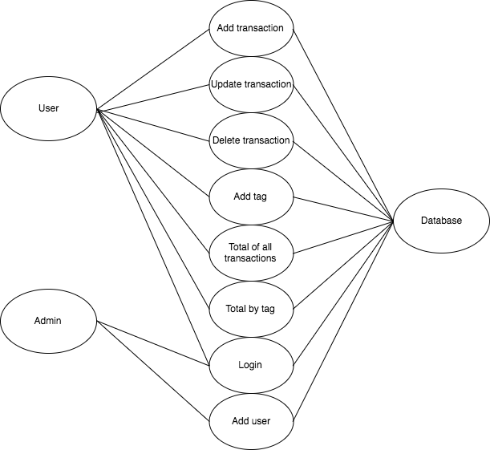

AD 2 Class Diagram

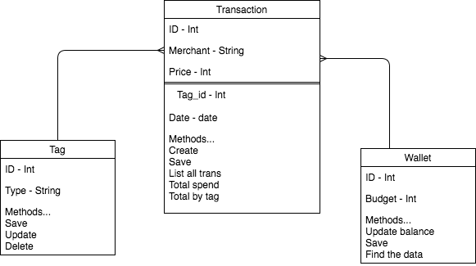

AD 3 Object Diagram

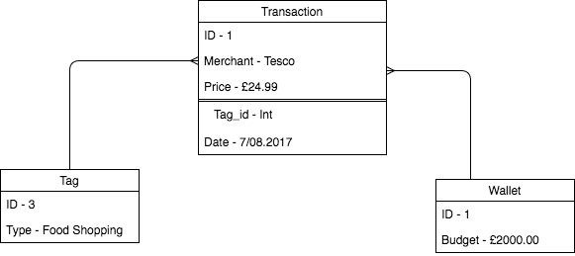

AD 4 Activity Diagram

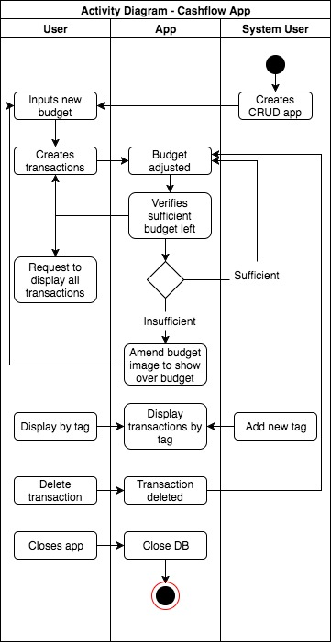

AD 5 Inheritance Diagram

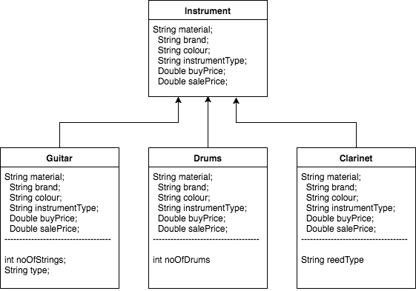

AD 6 Implementations Constraints Plan

|  |  |  |
| --- | --- | --- |
| Constraint | Possible Effect of constraint on product | Solution |
| Hardware and software platforms | May not be compatible with all devices.  Page may not work or it may run slowly - users may not use again as a result | Ensure compatible with older browsers |
| Performance requirements | If requirements are not met, product may run slowly or crash | Ensure minimum requirements are presented (if necessary) to users |
| Persistent storage and transactions | If considerable memory is required to save the data, it may slow down the device / product, may stop working.  Unless SQL injection is prevented, product open to attack. | Use preventative techniques for SQL injection. Ensure that data is stored as efficiently as possible. |
| Usability | If not intuitive or accessible to all, users may have difficulty using product - may choose not to use again. | Ensure that consideration is given at design stage and throughout to the usability of the product and accessibility for all prospective users (design for all). |
| Budgets | Product may not reach completion if over budget. May not be maintainable in future if not. | Stick to given budget and review progress regularly. |
| Time | Additional functionality may not be created if time runs out. The product may not be as good for the customer as a result.  Product may not be as user friendly as a result of time pressures. | Plan the creation process as much as possible and regularly iterate over the work completed to ensure completed on time. |